Q1. Installation of VS Code:

To download and install Visual Studio Code on a Windows 11 operating system, follow these steps:

1. Download VS Code:

- Go to the official [Visual Studio Code website] (https://code.visualstudio.com/).

- Click on the "Download for Windows" button. This will download the installer file (`VSCodeSetup.exe`).

2.Run the Installer:

- Locate the downloaded installer file and double-click to run it.

- Follow the installation wizard prompts:

- Accept the license agreement.

- Choose the destination folder.

- Select additional tasks such as creating a desktop icon or adding VS Code to the PATH (highly recommended).

- Click on "Install" to begin the installation process.

3.Finish Installation:

- Once the installation is complete, click on the "Finish" button. You can choose to launch Visual Studio Code immediately.

Prerequisites:

- Windows 11 operating system.

- Administrator privileges to install software.

- Internet connection to download the installer.

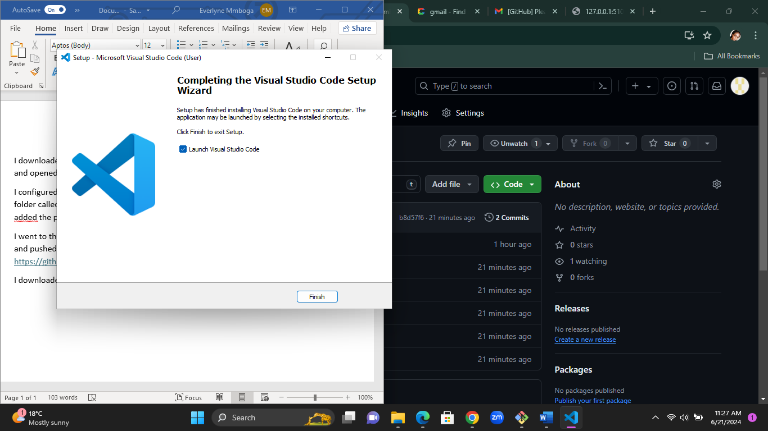

Q2. First-time Setup:

After installing VS Code, perform the following initial configurations and settings for an optimal coding environment:

1.Theme and Appearance:

- Go to `File > Preferences > Color Theme` to choose a preferred theme (e.g., Dark+, Light+).

2.Extensions:

- Install essential extensions by clicking on the Extensions icon in the Activity Bar.

- Recommended extensions:

- Python: for Python development.

- ESLint: for JavaScript linting.

- Prettier: for code formatting.

- GitLens: for enhanced Git capabilities.

- Live Server: for live preview of web projects.

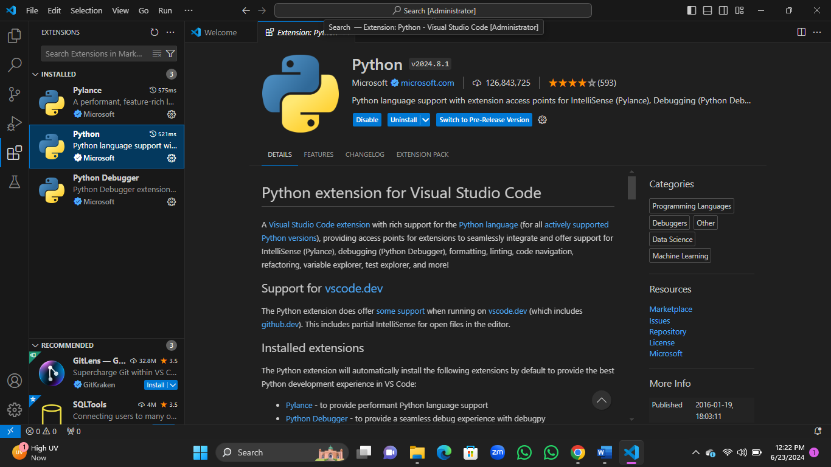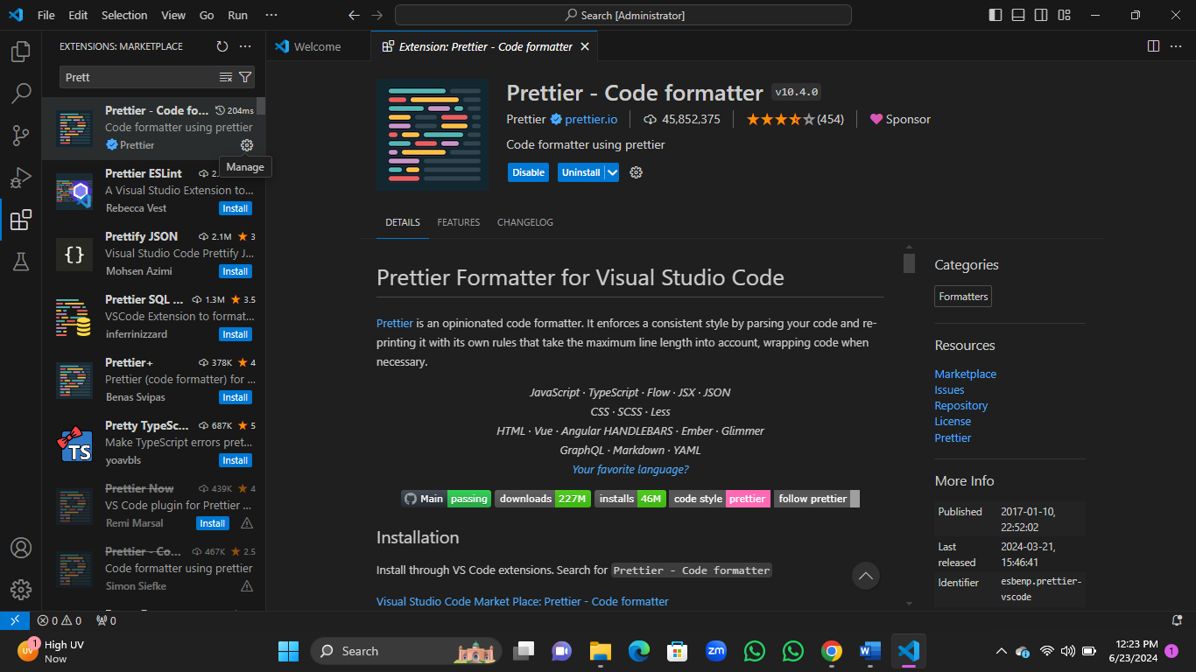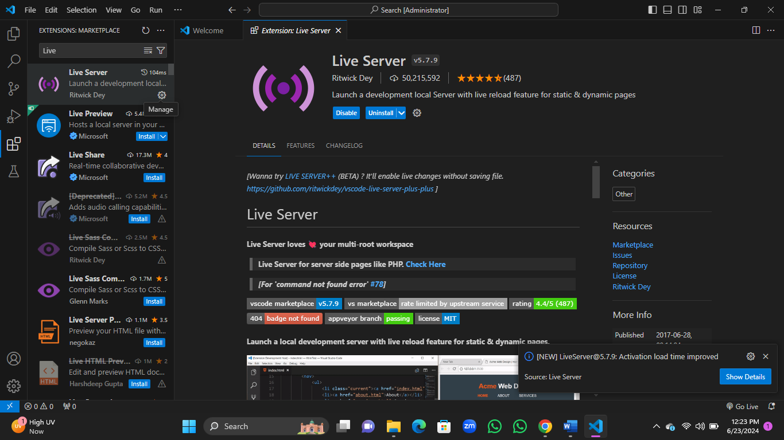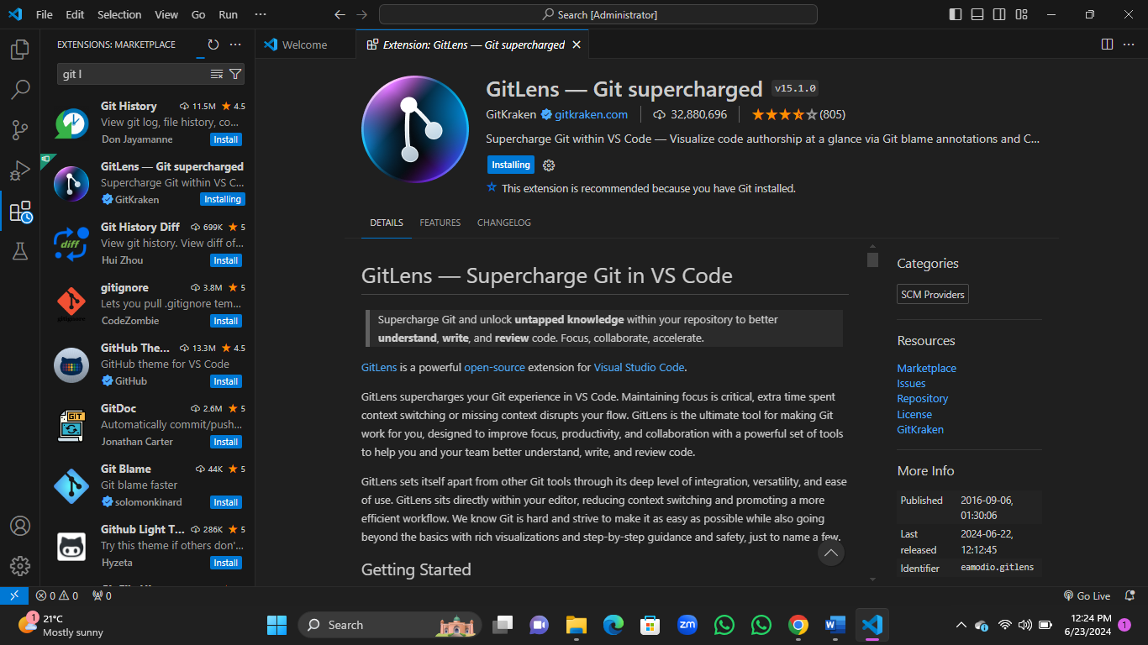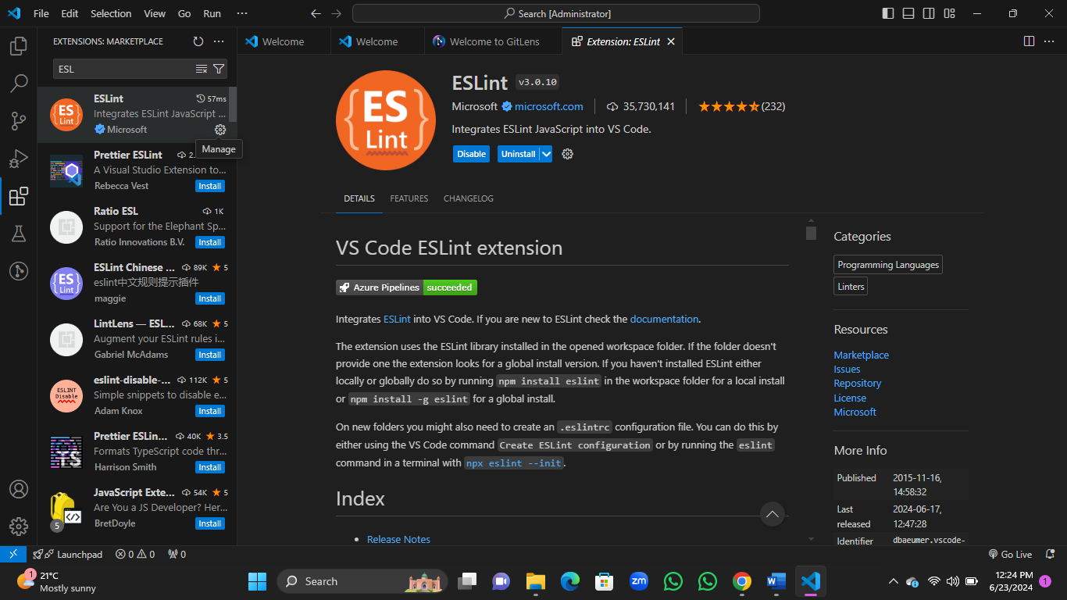

3. Settings:

- Navigate to `File > Preferences > Settings` to adjust various settings.

- Example adjustments:

- `editor.tabSize`: Set the number of spaces per tab.

- `editor.wordWrap`: Enable word wrap for long lines.

- `editor.fontSize`: Adjust the font size for better readability.

Q3. User Interface Overview:

The main components of the VS Code user interface are:

1.Activity Bar:

- Located on the far-left side, the Activity Bar allows you to switch between different views such as Explorer, Search, Source Control, Run and Debug, and Extensions.

2. Side Bar:

- The Side Bar changes content based on the selected activity. For example, the Explorer view shows the file and folder structure of your project.

3. Editor Group:

- The central area where files are opened for editing. Multiple files can be opened in tabs, and you can split the editor to view files side by side.

4. Status Bar:

- Located at the bottom of the window, the Status Bar provides information about the current file, errors, warnings, Git branch, and other status indicators.

Q4. Command Palette:

The Command Palette is a powerful tool in VS Code that allows you to access various commands and features quickly.

- Accessing the Command Palette:

- Press `Ctrl+Shift+P` (Windows) or `Cmd+Shift+P` (Mac).

- Examples of Common Tasks:

- Open a file: `> Open File`

- Change the color theme: `> Preferences: Color Theme`

- Install extensions: `> Extensions: Install Extensions`

- Run tasks: `> Tasks: Run Task`

Q5. Extensions in VS Code:

Extensions play a crucial role in enhancing the functionality of VS Code.

-Finding Extensions:

- Click on the Extensions icon in the Activity Bar.

- Use the search bar to find specific extensions.

- Installing Extensions:

- Click on the `Install` button next to the extension you want to install.

- Reload VS Code if prompted.

-Managing Extensions:

- Disable or uninstall extensions from the Extensions view.

- Update extensions when updates are available.

- Essential Extensions for Web Development:

- HTML, CSS, and JavaScript: Basic language support.

- Prettier: Code formatter.

- ESLint: Linting for JavaScript.

- Live Server: Real-time preview.

Q6. Integrated Terminal:

The integrated terminal allows you to run command-line tasks within VS Code.

-Opening the Integrated Terminal:

- Go to `View > Terminal` or press `Ctrl+`` (Windows) or `Cmd+`` (Mac).

- Using the Integrated Terminal:

- You can run commands, scripts, and tasks directly from the terminal.

- Multiple terminals can be opened and managed within the same interface.

- Advantages of using integrated terminal:

- Seamless integration with your development environment.

- Ability to run tasks without switching windows.

File and Folder Management:

Managing files and folders in VS Code is straightforward.

- Creating Files and Folders:

- Right-click in the Explorer view and select `New File` or `New Folder`.

- Use the `File > New File` or `File > New Folder` menu options.

- Opening Files and Folders:

- Use `File > Open File` or `File > Open Folder` to open existing files or projects.

- Drag and drop files or folders into the VS Code window.

- Navigating Between Files and Directories:

- Use the Explorer view to click on files and folders.

- Use `Ctrl+P` (Windows) or `Cmd+P` (Mac) to quickly search and open files by name.

Q8. Settings and Preferences:

VS Code settings can be customized to suit your preferences.

- Accessing Settings:

- Go to `File > Preferences > Settings`.

- Changing Theme:

- `File > Preferences > Color Theme`.

- Adjusting Font Size:

- Search for `editor.fontSize` in the settings and adjust the value.

- Customizing Keybindings:

- Go to `File > Preferences > Keyboard Shortcuts`.

- Search for commands and set custom keybindings.

Q9. Debugging in VS Code:

To debug a simple program in VS Code:

1. Set Up Debug Configuration:

- Go to the Run and Debug view in the Activity Bar.

- Click on `create a launch.json file` to set up a new debug configuration.

2. Add Breakpoints:

- Click in the gutter next to the line numbers to set breakpoints.

3. Start Debugging:

- Click on the green play button or press `F5` to start debugging.

4. Key Debugging Features:

- Step over, step into, and step out of functions.

- Watch variables and view their values.

- Inspect the call stack.

Q10. Using Source Control:

Integrating Git with VS Code for version control:

1. Initialize a Repository:

- Open the folder you want to initialize as a Git repository.

- Go to the Source Control view and click on `Initialize Repository`.

2. Making Commits:

- Stage changes by clicking the `+` icon next to changed files.

- Enter a commit message and click the checkmark icon to commit.

3. Pushing Changes to GitHub:

- Ensure you have a remote repository on GitHub.

- Set up the remote by running `git remote add origin <repository-url>` in the integrated terminal.

- Push changes using the `Push` option in the Source Control view or by running `git push` in the terminal.

By following these steps, you can effectively set up, configure, and use Visual Studio Code for a productive development experience.

2. Making Commits:

- Stage changes by clicking the `+` icon next to changed files.

- Enter a commit message and click the checkmark icon to commit.

3. Pushing Changes to GitHub:

- Ensure you have a remote repository on GitHub.

- Set up the remote by running `git remote add origin <repository-url>` in the integrated terminal.

- Push changes using the `Push` option in the Source Control view or by running `git push` in the terminal.